**Day 3**

**C++ Recursion, Arrays, Strings, Structures**

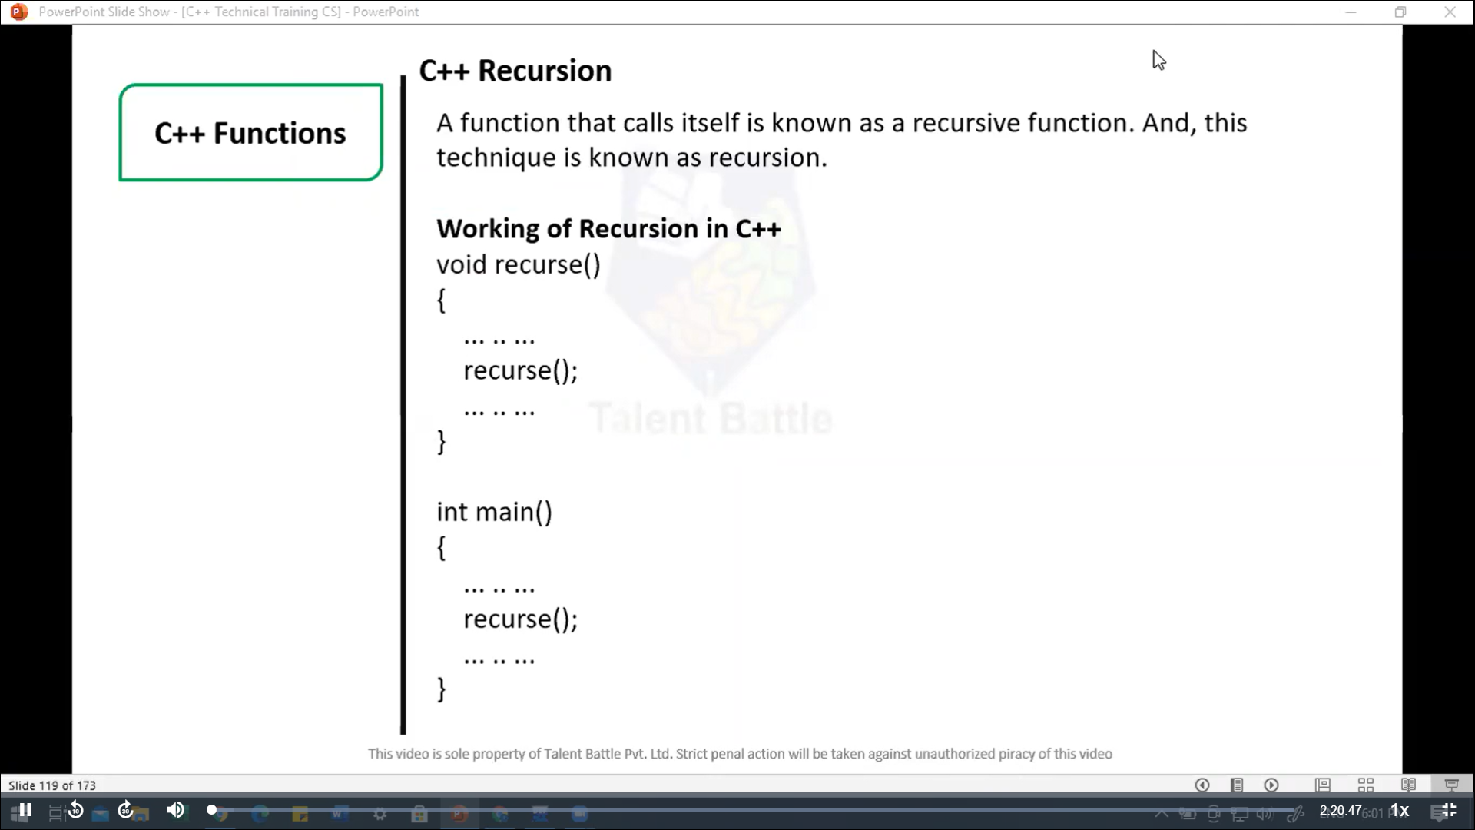

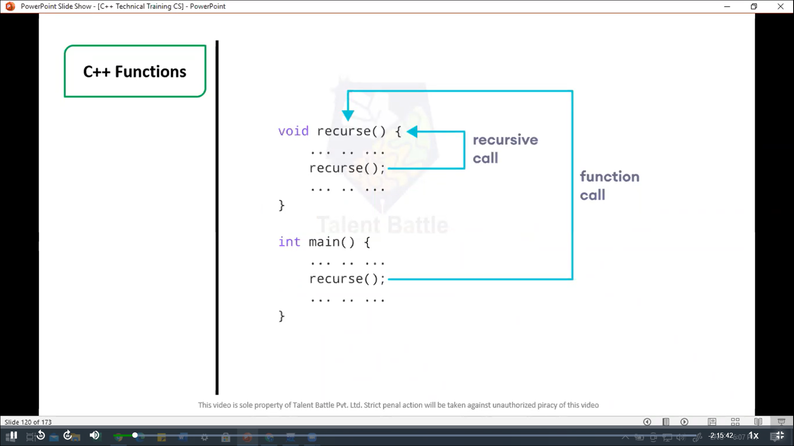

// C++ Recursion, Arrays, Strings, Structures

// Factorial of n = 1*2*3*...*n

#include <iostream>

using namespace ***std***;

int *factorial*(int); // functoin prototype

int *main*(){

  int n***,*** result;

  cout ***<<*** "Enter a non-negative number: ";

  cin ***>>*** n;

  result = *factorial*(n);

  cout ***<<*** "Factorial of " ***<<*** n ***<<*** " = " ***<<*** result;

  return 0;

}

int *factorial*(int ***n***) {

  if(n > 1){

    cout ***<<*** n ***<<*** " " ***<<*** n\**factorial*(n-1) ***<<*** endl;

    return n * *factorial*(n-1);

  } else {

    return 1;

  }

}

**==========================================**

**Output:**

**Enter a non-negative number: 5**

**Factorial of 5 = 120**

**--------------------------------**

**Process exited after 2.145 seconds with return value 0**

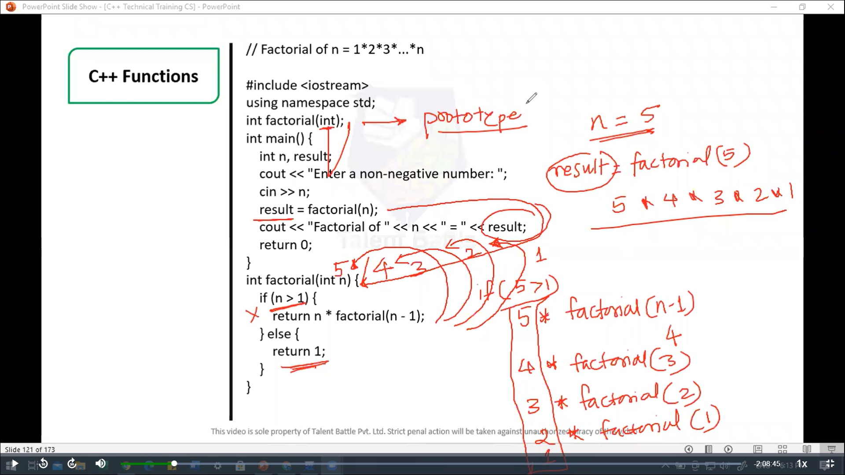

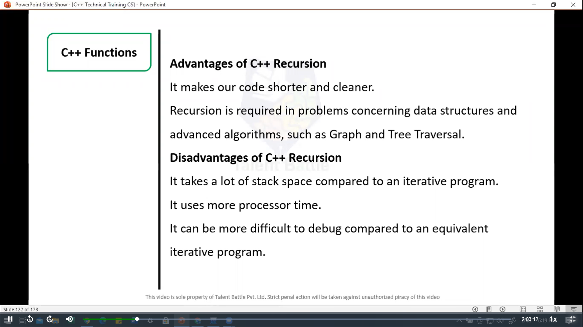

//======================================================

// C++ Return by Reference

/*

In C++ Programming, not only can you pass values by reference

to a function but you can also return a value by reference.

*/

#include <iostream>

using namespace ***std***;

// Global variable

int num;

// function declaration

int& *test*();

int *main*(){

*test*() = 5;

  cout *<<* num;

  return 0;

}

int& *test*(){

  return num;

}

**=============================================================**

**5**

**--------------------------------**

**Process exited after 0.1432 seconds with return value 0**

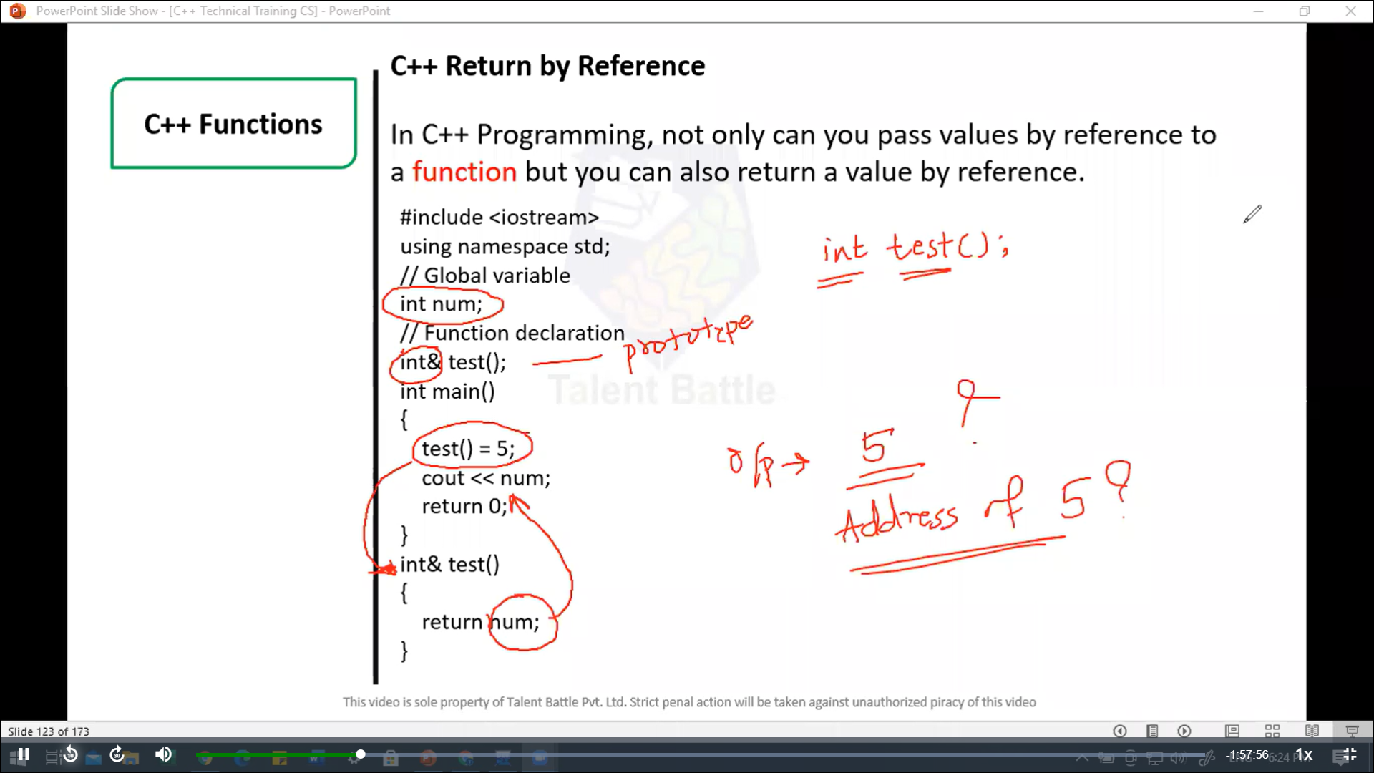

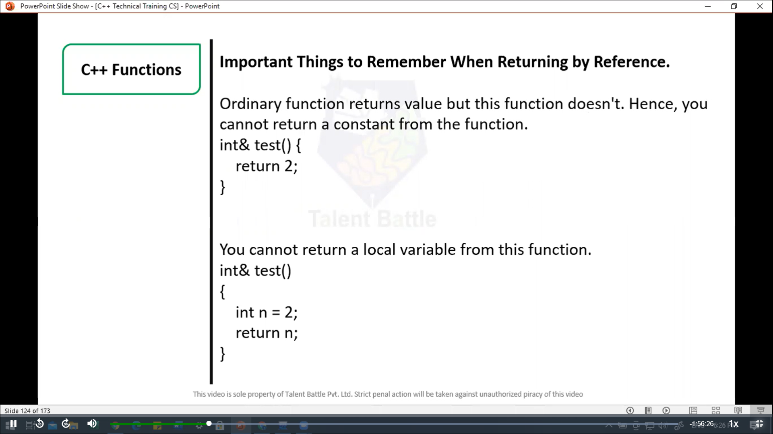

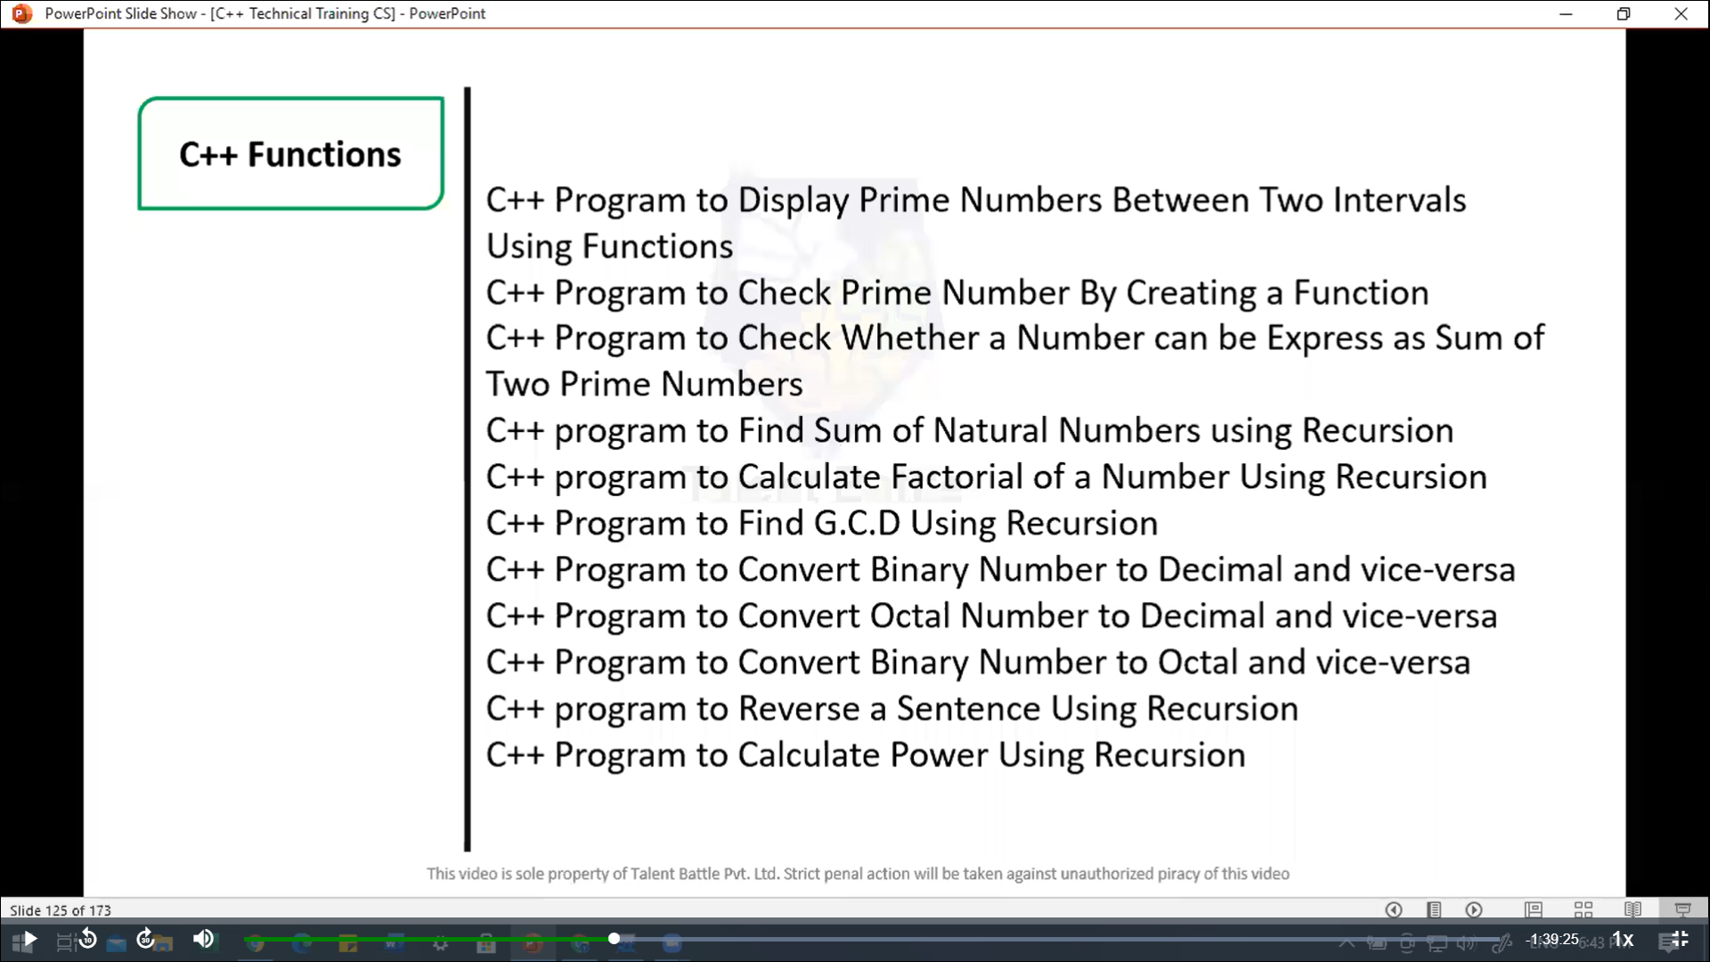

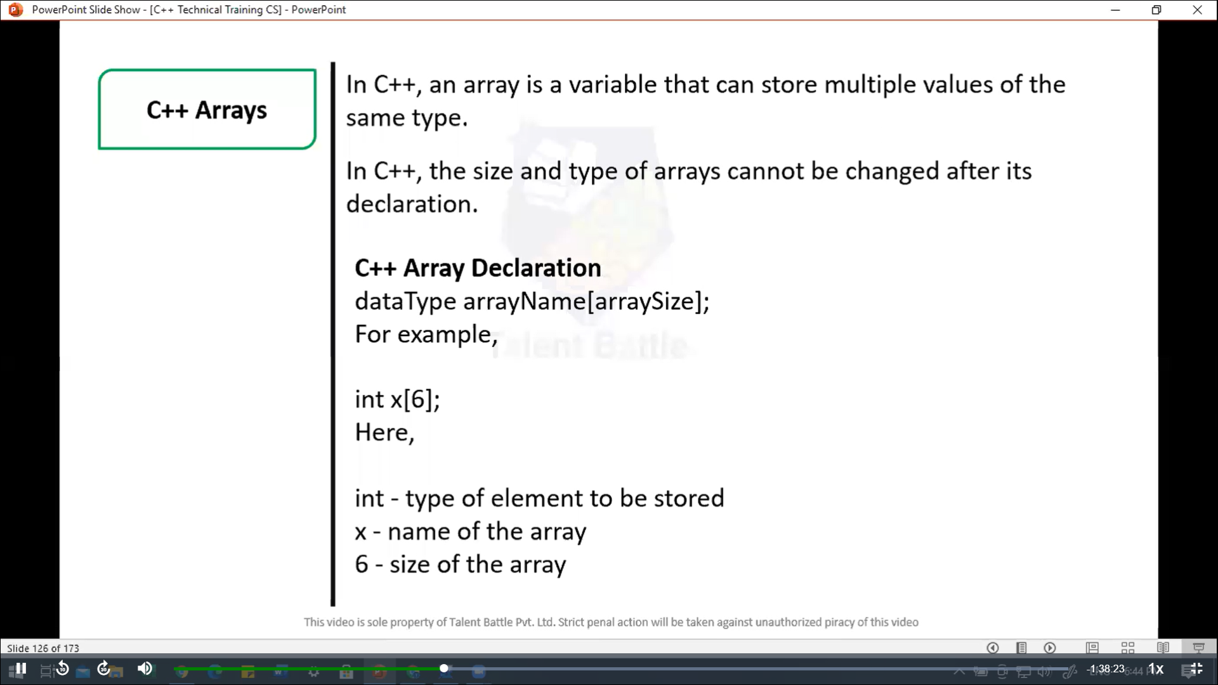

//===============================================

// C++ Program to display prime number between two intervals using functions

#include <iostream>

using namespace ***std***;

// function to check if a number is prime

bool *isPrime*(int ***num***){

  if(***num*** <= 1) // Prime numbers are greater than 1

    return **false**;

  for(int i = 2; i <= ***num*** / 2; ++i){

    if(***num*** % 2 == 0)

      return **false**;

  }

  return **true**;

}

// function to print prime numbers between two intervals

void *printPrimeInRange*(int ***start,*** int ***end***){

  cout *<<* "Prime number between " *<<* ***start*** *<<* " and " *<<* ***end*** *<<* " are: ";

  for(int i = ***start***; i <= ***end***; ++i){

    if(*isPrime*(i)){

      cout *<<* i *<<* " ";

    }

  }

  cout *<<* *endl*;

}

int *main*(){

  int start***,*** end;

  // input from the user

  cout *<<* "Enter the starting number: ";

  cin *>>* start;

  cout *<<* "Enter the ending number: ";

  cin *>>* end;

  // call function to display prime numbers between the range

*printPrimeInRange*(start***,*** end);

  return 0;

}

/*

Enter the starting number: 1

Enter the ending number: 15

Prime number between 1 and 15 are: 2 3 5 7 9 11 13 15

--------------------------------

Process exited after 9.728 seconds with return value 0

*/

//=======================================================

// C++ program to check prime number by creating a function

#include<iostream>

using namespace ***std***;

// function to check if a number is prime

bool *isPrime*(int ***num***){

  if(***num*** <= 1) // prime number are greater than 1

  {

    return **false**;

  }

  for(int i = 2; i <= ***num***/2; ++i){

    if(***num*** % i == 0) // if the number is divisible by any number other than 1 and itself

    {

      return **false**;

    }

  }

  return **true**; // If no divisors found, it is prime

}

int *main*(){

  int number;

  // Input from the user

  cout *<<* "Enter a number: ";

  cin *>>* number;

  // check if the number is prime using the function

  if(*isPrime*(number)){

    cout *<<* number *<<* " is a prime number." *<<* *endl*;

  } else {

    cout *<<* number *<<* " is not a prime number." *<<* *endl*;

  }

  return 0;

}

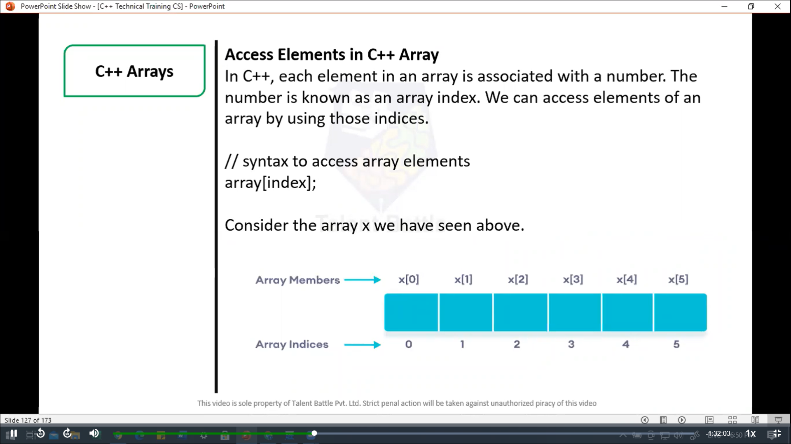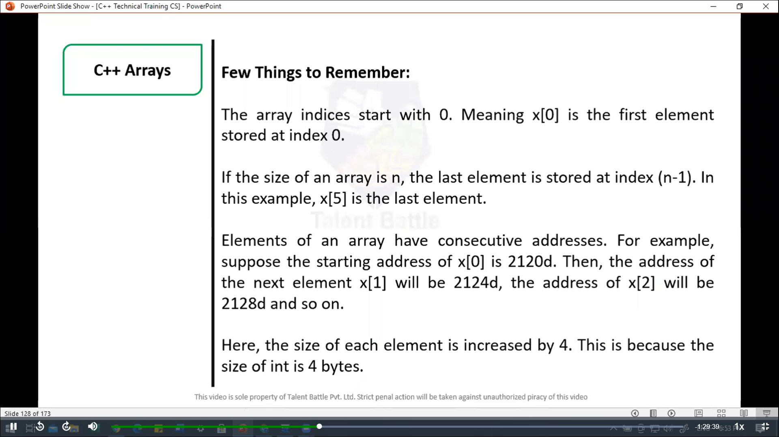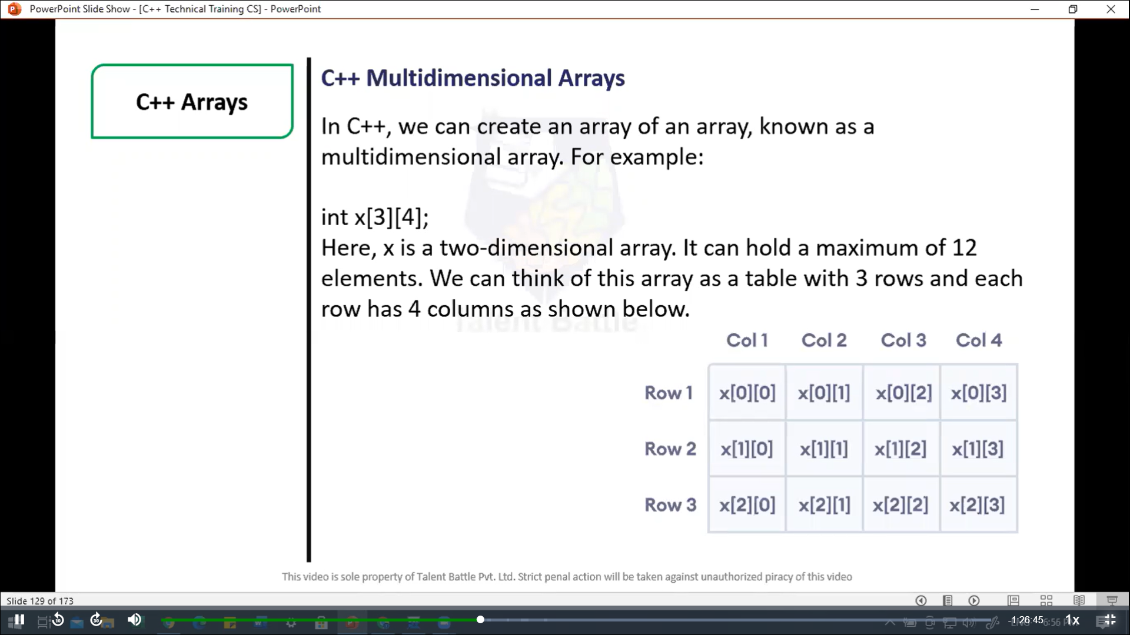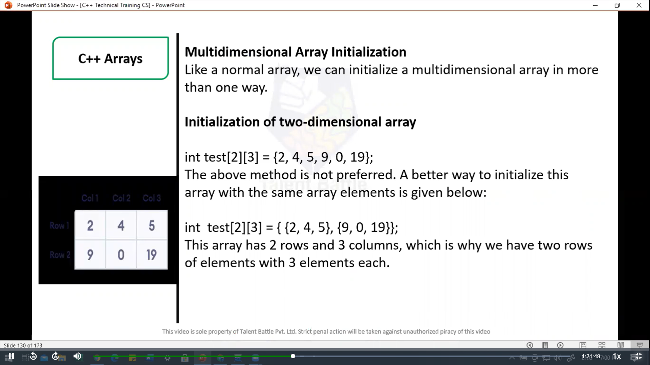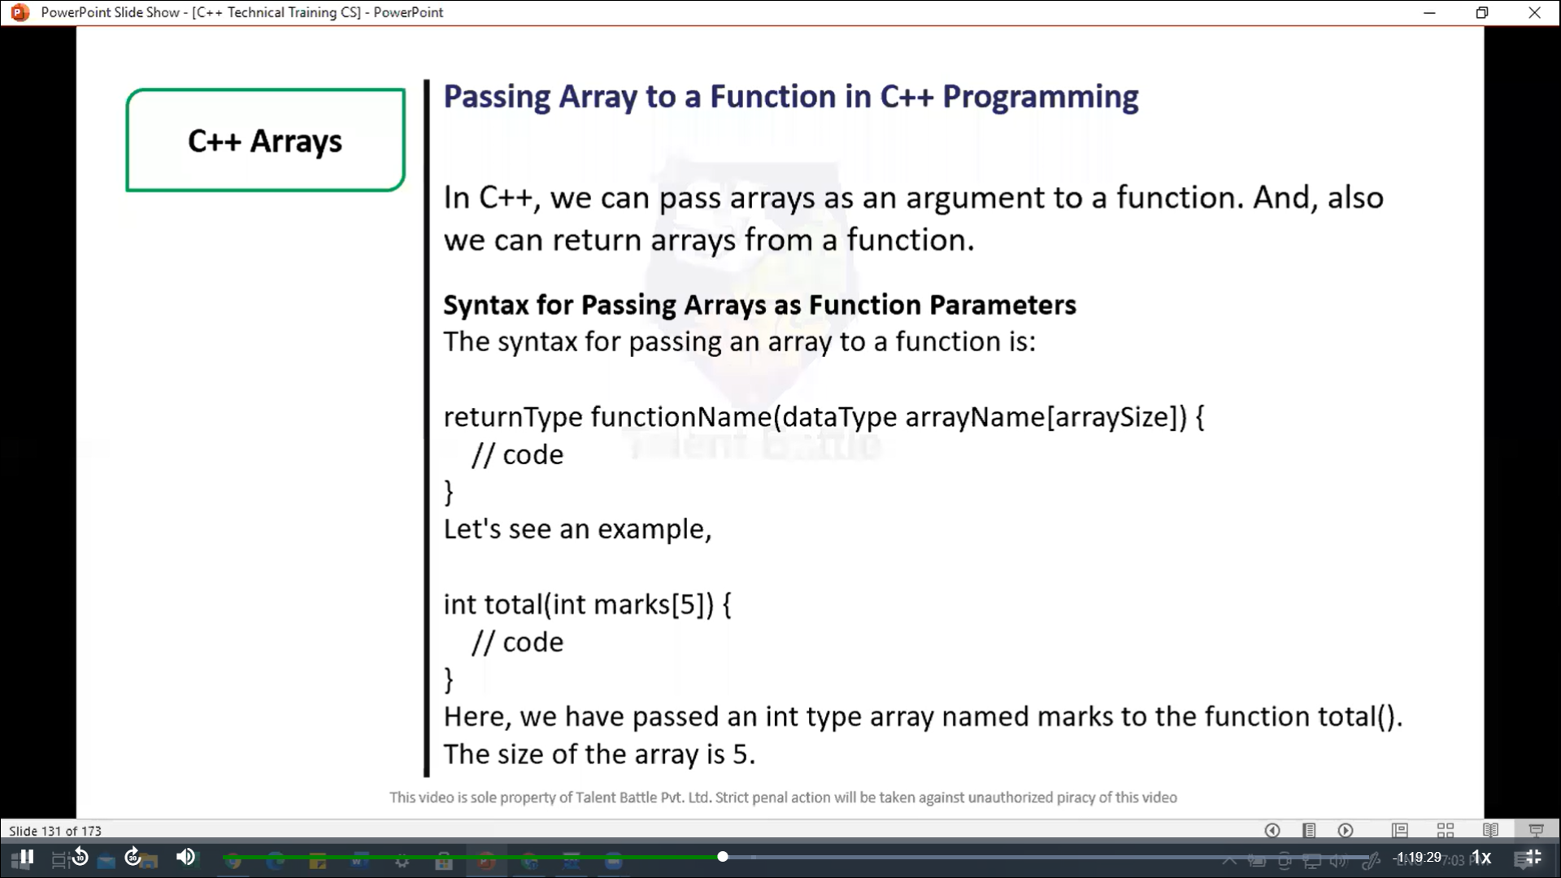

//===============================================

// C++ Program to display marks of 5 students

#include <iostream>

using namespace ***std***;

// declare function to display marks

// take a 1d array as parameter

void *display*(int ***m***[5]){

  cout *<<* "Displaying marks: " *<<* *endl*;

  // display array elements

  for(int i = 0; i < 5; ++i){

    cout *<<* "Student " *<<* i + 1 *<<* ": " *<<* ***m***[i] *<<* *endl*;

  }

}

int *main*(){

  // declare and initialize an array

  int marks[5] = {88***,*** 76***,*** 90***,*** 61***,*** 69};

  // call display function

  // pass array as argument

*display*(marks);

  return 0;

}

/*

Displaying marks:

Student 1: 88

Student 2: 76

Student 3: 90

Student 4: 61

Student 5: 69

--------------------------------

Process exited after 0.06605 seconds with return value 0

*/

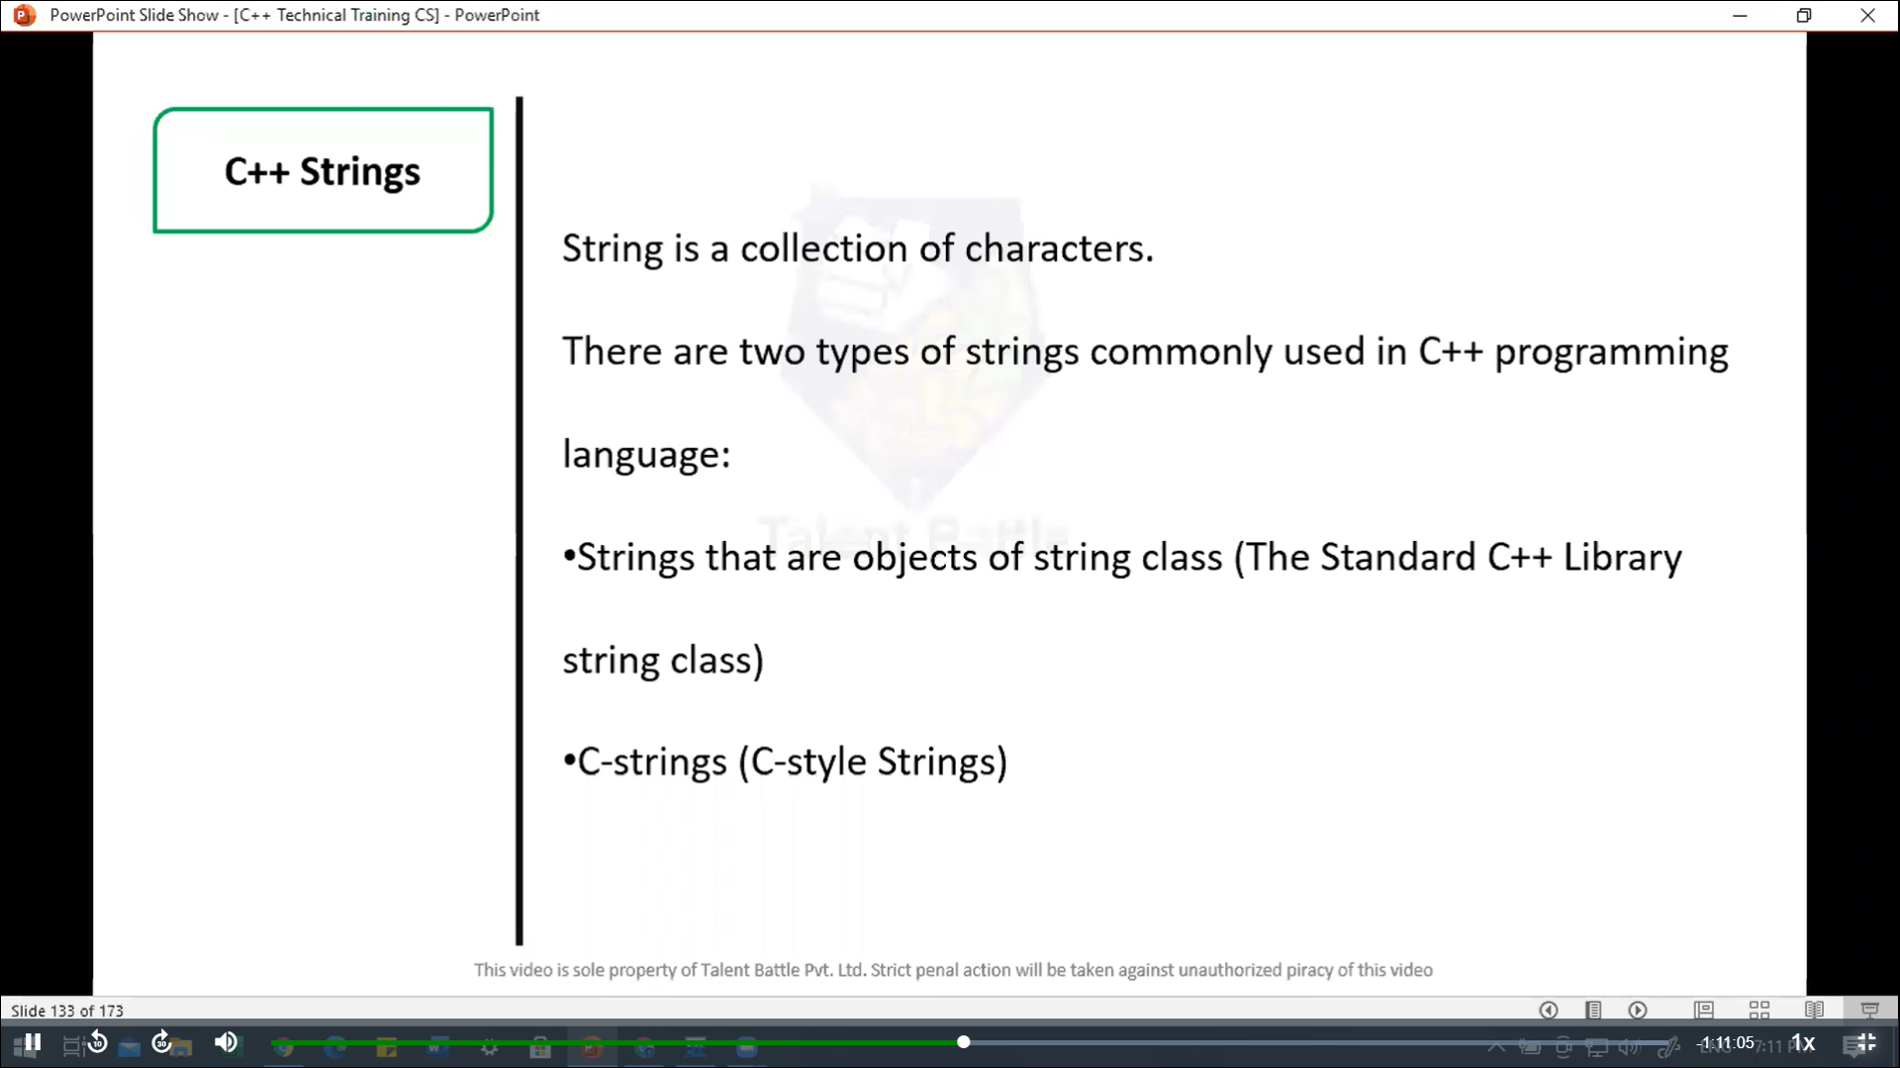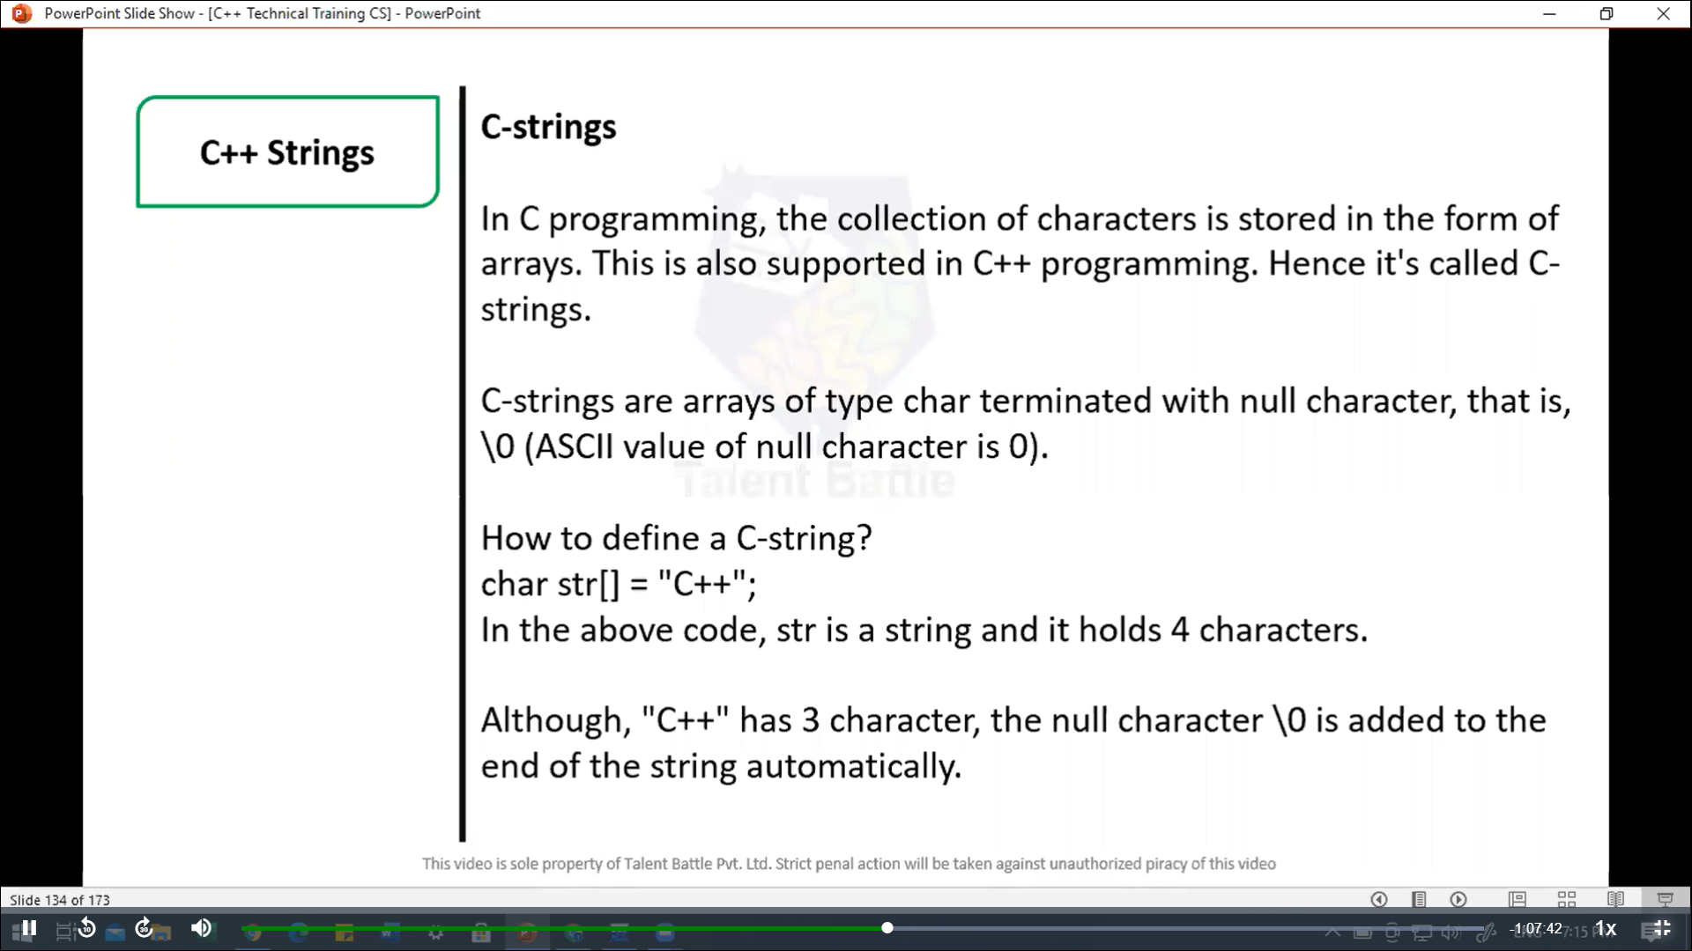

//=====================================================

// C++ Program to display a string entered by user.

/*

The extraction operator >> works as scanf() in c and considers

a space " " has a terminating character.

*/

#include<iostream>

using namespace ***std***;

int *main*(){

  char str[100];

  cout *<<* "Enter a string: ";

  cin *>>* str;

  cout *<<* "You entered: " *<<* str *<<* *endl*;

  cout *<<* "**\n**Enter another string: ";

  cin *>>* str;

  cout*<<* "You entered: " *<<* str *<<* *endl*;

  return 0;

}

/*

Enter a string: best

You entered: best

Enter another string: C++_language

You entered: C++_language

--------------------------------

Process exited after 16.61 seconds with return value 0

*/